Paper Towel Rolls

[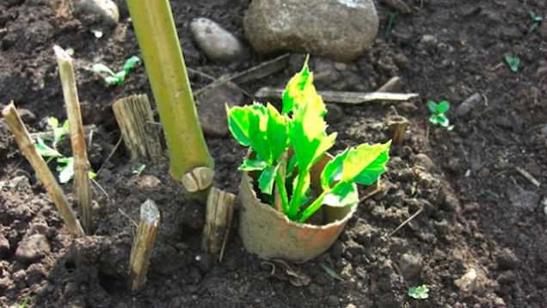](https://balconygardenweb-lhnfx0beomqvnhspx.netdna-ssl.com/wp-content/uploads/2016/06/17nifjo1gbc1djpg.jpg)

Instead of throwing out the paper towel roll, [use it in the garden](https://lifehacker.com/5912590/use-old-paper-towel-rolls-in-the-garden-to-protect-seedlings-from-pests). Cut it into peices and press it into the soil around your newly planted seedlings to give them a extra protection from slugs and other ground dwelling pests. You can also use paper towel rolls as seed starters (*you can also use toilet paper rolls)